Case 6-AFR-DR Congo-Mask-Songye Kifwebe-**1910**

Note: The Democratic Republic of the Congo (DR Congo) has been known as, in chronological order, the Congo Free State, Belgian Congo, the Republic of Congo-Léopoldville, the Democratic Republic of the Congo and the Republic of Zaire, before returning to its current name the DR Congo.

Note: The Kongo people (singular: Mukongo, pl. Bakongo) speak Kikongo, a Bantu language, who have lived along the Atlantic coast of Central Africa, in a region that, by the 15th century, was a centralized and well-organized Kongo Kingdom but is now a part of three countries: DR Congo, the Republic of the Congo and Angola.

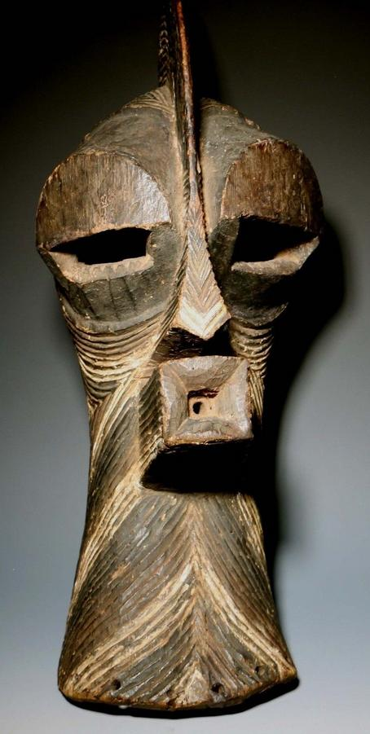

**Country: Congo (D.R.C.)**

**People: Songye**

**Period: Early 20th Century**

**Material: Wood/Pigmentation**

**Dimensions: L x W x D (cm)**

**Weight: lb 7 oz (kg gm)**

**Description:**

**A large Songye Kifwebe mask.  The mask is a classic Kifwebe stylized mask with a sagittal crest,** **protruding eyes, nose and quadrangular mouth.  Incised lines throughout with black and white pigmentation.  Raffia holes at sides.**

Price:

US $3,750.00